MYSQL STORED PROCEDURES
Examples and Practice Exercises for MySQL Workbench

1. Setup: Employees Table
CREATE DATABASE IF NOT EXISTS employeedb1;
USE employeedb1;
CREATE TABLE IF NOT EXISTS employees (
emp_id INT PRIMARY KEY,
emp_name VARCHAR(50),
dept_id INT,
salary DECIMAL(10,2)
);
INSERT INTO employees VALUES
(101,'Rahul',1,50000),
(102,'Priya',2,65000),
(103,'Anil',1,55000),
(104,'Sneha',3,70000),
(105,'Kiran',2,48000);

2. Verify Data
Question: Display all employee records. 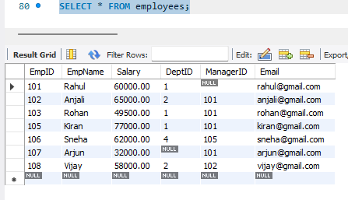

Procedure 1 – Display All Employees
Question: Create a procedure that displays all employees.

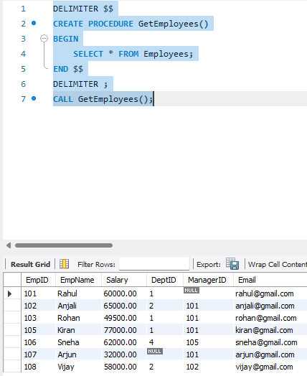

Procedure 2 – IN Parameter
Question: Create a procedure that accepts an employee ID and displays that employee's details.

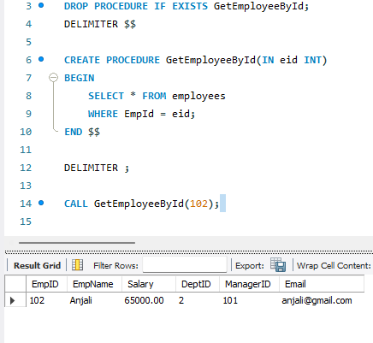

Procedure 3 – Update Salary
Question: Create a procedure that accepts employee ID and amount, then increases the employee's salary.

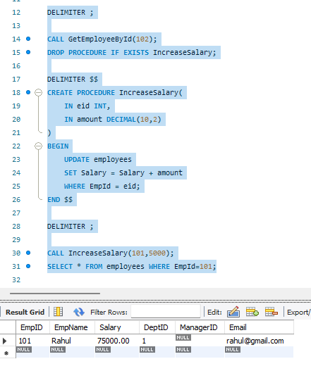

Procedure 4 – Aggregate Function
Question: Create a procedure to calculate the average salary of all employees.

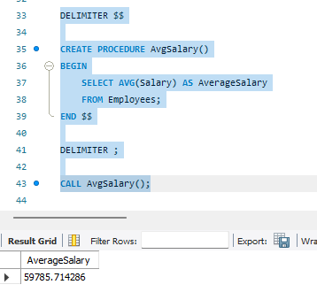

Procedure 5 – JOIN
Question: Create a procedure to display employee name, department name and salary. Run the department setup first.

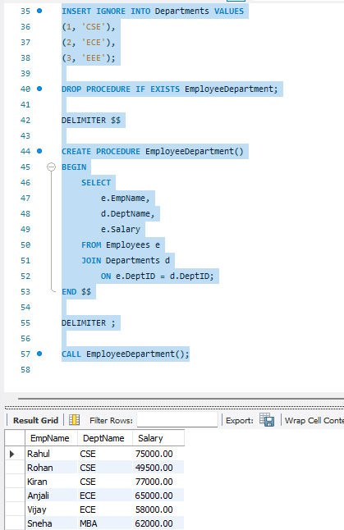

Procedure 6 – GROUP BY and AVG
Question: Create a procedure to display department-wise employee count and average salary.

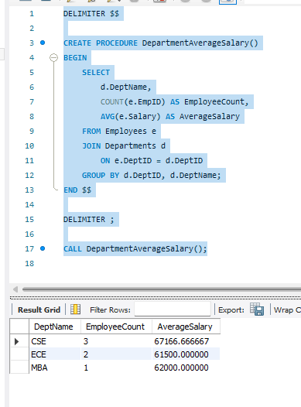

Procedure 7 – IF...ELSE
Question: Display High Salary if salary is at least 60000; otherwise display Low Salary.

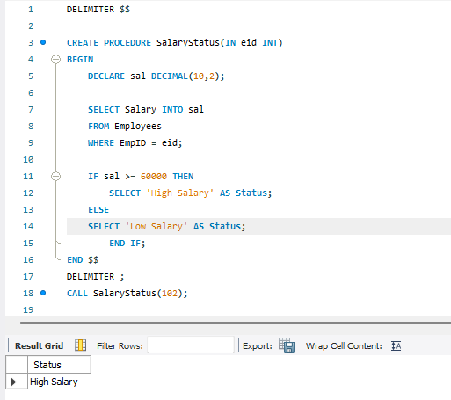

Procedure 8 – OUT Parameter
Question: Return the total number of employees using an OUT parameter.

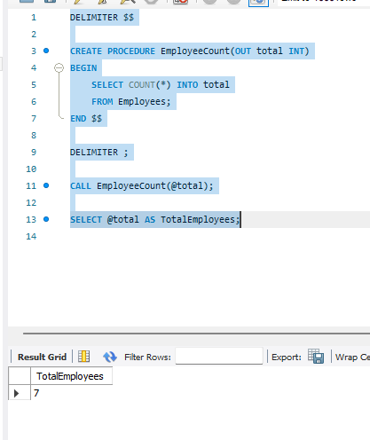

Procedure 9 – INOUT Parameter
Question: Receive a bonus through an INOUT parameter and add 5000 to it.

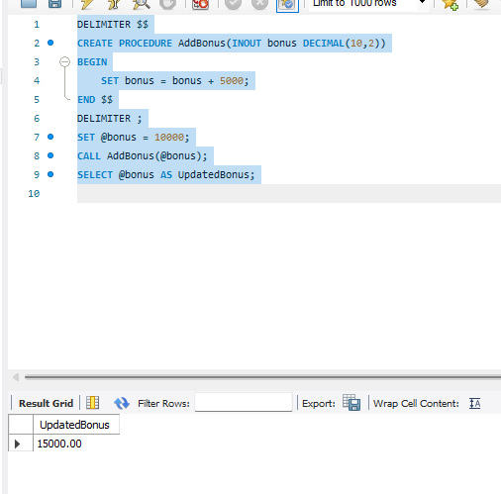

Procedure 10 – Transaction
Question: Transfer an amount from one employee salary record to another using START TRANSACTION and COMMIT.

